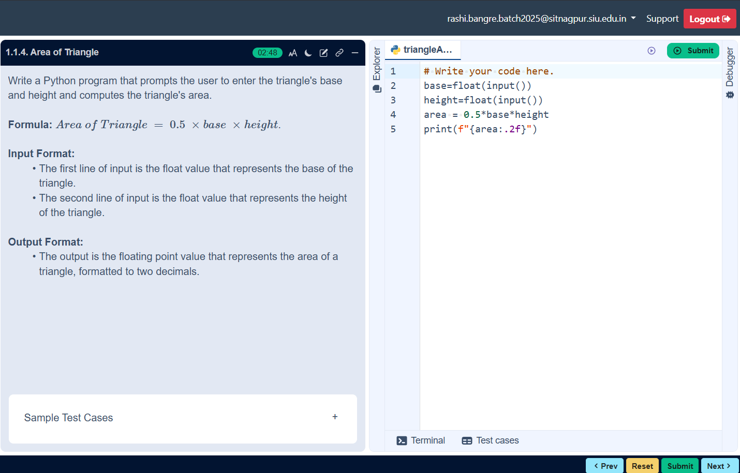
ALGORITHM
Step 1: Start
Step 2: Input base, height
Step 3: Calculate
area=0.5*base*height
Step 4: Print area
Step 5: Stop

FLOWCHART

AREA OF TRIANGLE

